**Journal Title**

ISSN

www.

stmjournals.com



**SMART PERSONAL SAFETY DEVICE USING IoT**

***Adwaith Shaji Gayathri V. S.***

Electrical and Electronics Engineering, Electrical and Electronics Engineering,

UKF College of Engineering and Technology UKF College of Engineering and Technology

Kollam, India Kollam, India adwaith627@gmail.com vsgayathri63@gmail.com

# *Mithra M. Lal Mrs.Ashida Pradeep*

Electrical and Electronics Engineering, Assistant Professor, Dept. of EEE

UKF College of Engineering and Technology UKF College of Engineering and Technology

Kollam, India Kollam, India mithramlal17@gmail.com ashidapradeep@gmail.com

# *Abstract*

*Our goal is to identify a considering the rapid advancement of science and technology and our heavy dependence on technological features, a solution to this important problem for women. We are focusing to make a smart personal safety device that helps women’s and all peoples who need help or an extra security. This project not only helps women’s but also helps children, old age people and disabled people. The design supports a smart location and tracking system and alert notification, GPS, GSM, Audio video recording facility, and a face-recognition image capture system and to minimize the weight of the model. We implemented Li-Ion battery. The high-quality camera and voice recorder cooperate with GSM system and send the visuals and recordings to nearest police station or relatives. It not only sending it stores the visual and recording in cloud storage for legal purposes .The suggested model also includes an electric shock with a wireless system activator and a siren. The design features have been carefully considered and confirmed to provide women with the best safety tool available.*

*Keywords: IoT, Smart bag, Woman Safety, Li-ion battery, GPS, GSM, Video recording.*

# INTRODUCTION

Ensuring women's safety stands out as a paramount concern across nations today. Despite contributing approximately half of the development efforts in today's competitive landscape, women face a concerning lack of security in our society. This insecurity restricts their freedom of movement, undermining their empowerment and hindering national progress. Overcoming this challenge entails addressing various issues like gender-based violence, discrimination, harassment, and inequality. Effective promotion of women's safety necessitates holistic strategies incorporating legal frameworks, social norms, education, awareness programs, and robust support systems. Prioritizing women's safety is crucial for fostering a safer and more inclusive global environment.

This project proposes a wearable carry bag as an innovative solution for enhancing women's security. Integrating IoT and GPS technologies, the system caters to the needs of women facing threats of

*Journal Short Title (2014) 1 10 © STM Journals 2013. All Rights Reserved*

violence. Its core objective is to develop a cutting-edge system utilizing Raspberry Pi, GSM, and GPS technologies. This system empowers individuals under threat to respond promptly, significantly reducing instances of crimes against women. During emergencies such as harassment, victims can activate the system either manually through a wireless button or automatically through a pulse rate sensor, sending live location data, video, and audio evidence to nearby police stations and relatives. The integration of wireless buttons, camera modules, microphone modules, GPS modules, and GSM modules enhances the system's functionality, with the Raspberry Pi Zero 2W board serving as the central control unit.

The project also introduces an IoT-based approach to assist women feeling unsafe, reflecting a novel and rapidly evolving concept. By gathering data from sensors and comparing values against predefined thresholds, this device triggers appropriate actions, providing a proactive safety mechanism for women in vulnerable situations.

# PROPOSED SYSTEM

Smart personal safety device using IoT works by using some combination of components and technologies. The security system is controlled by a RASPBERRY Pi Zero 2W model board and it is programmed using c program. It has both GPS system and GSM system integrated together for compact size.

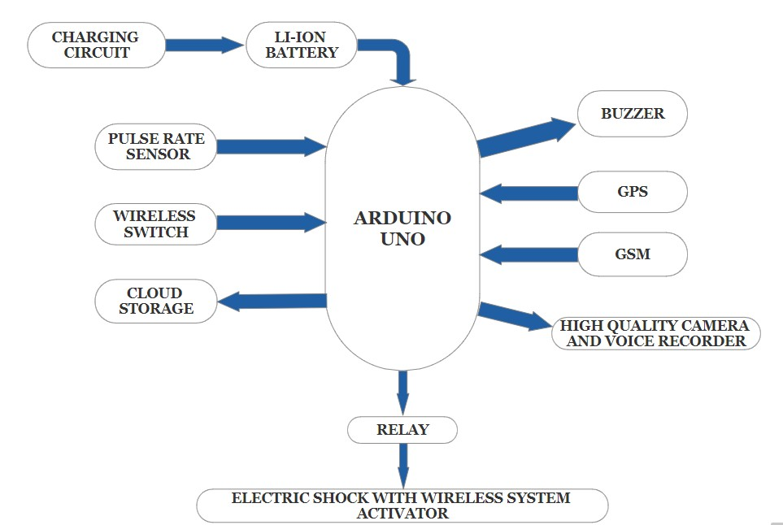

Fig.1. Block diagram of proposed system

In this block diagram ,the system is equipped with a high-definition ESP32 camera and a microphone for recording evidence of the attacker and GPS system to track the live location of victim and all these details are send using GSM system to the nearby police station and to the relatives. The most important role of this project is that it protects women, children and old age people from attacker. There are three ways to activate the security system. First method is by just pressing the wireless switch that is implemented using ESP8622 like a key chain, then the system activates automatically by sensing the pulse rate using pulse rate sensor and the last way is that it is equipped with electric shocker for protection from attacker while implementing a wireless switch in that electric shocker to activate. The system uses a Li-ion battery of 7.4V for power supply which is small compact and rechargeable. The system is connected to blynk application for the ease of use. The smart personal safety device using IoT is a most important tool that must be with everyone in this world.

Raspberry pi zero 2W is used for the implementation of smart personal safety device. Raspberry Pi has everything a computer needs to function – just in a tiny package. The GPU and CPU are in a single, integrated circuit. Other components, including a USB port, RAM, and SD card slot are soldered on. The SD card is typically used to hold the operating system, and potentially some more files.

Here we are using integrated module for GPS and GSM which is compact in size. GPRS and GSM are technologies that deal with mobile communications services. GPS is about satellite navigation services. GPRS and GSM can be accessed via GSM-compatible mobile phones.

The ESP32-CAM board comes with an OV2640 camera module by default, which is capable of capturing JPEG images and streaming video. The OV2640 is a 2-megapixel camera sensor commonly used in embedded systems. Features of ESP32-CAM are;

* Camera Capabilities: It can capture images in various resolutions (160x120 to 1600x1200 pixels) and supports video streaming (QVGA resolution).
* Storage Options: Images and videos can be stored on an external SD card or sent over the network.
* Low Power Modes: The ESP32-CAM can be put into low-power modes to conserve energy, suitable for battery-powered applications.
* Programming Interface: It can be programmed using the Arduino IDE with the ESP32 board support package, making it accessible to a wide range of developers.

A voice recorder is an electronic device or software application designed to capture and store audio recordings. These recordings can be made using built-in microphones or external ones, depending on the device's design. A touch sensor is a type of device that captures and records physical touch or embrace on a device and/or object. It enables a device or object to detect touch or near proximity, typically by a human user or operator**.** A rechargeable battery known as a lithium-ion or Li-ion battery stores energy through the reversible reduction of lithium ions. It is the most common type of battery utilized in electric vehicles and portable consumer electronics. Li-ion batteries have high energy densities, low self-discharge, and no memory effect when compared to other technologies for rechargeable batteries. A pulse rate sensor measures pulse and heart rate. Here we are using it as a system activator.

# CIRCUIT DIAGRAM OF EMERGENCY ALLERT SYSTEM



Fig.2.Circuit diagram of proposed system

In this circuit diagram the system is equipped with a SIM800L GSM module, a GPS NEO6M GPS module, a ARDUINO NANO board and a battery package. The main goal of this circuit is to provide a fast and efficient alert system. The circuit has 2 switches assigned with 2 functions. The first switch act as a calling switch that is when we press the first switch the prototype makes call to a specific phone number of parents or relatives. The other switch function as a text message sending switch that include the real time location. While pressing the second button the circuit sends the real time location to the desired phone number.

\ x m

# CONCLUSION

The proposed system aims to reduce the incidence of crimes against women, ensuring a sense of safety and comfort for every woman in society. A recent survey revealed that 53% of employed women in India feel insecure, highlighting the need for such initiatives. This system facilitates women's independent and unrestricted travel.

This initiative has been effectively executed to offer a contemporary self-defense solution for women's security. Furthermore, its rapid processing capabilities make it ideal for real-time applications and continuous monitoring, promising enhanced safety for all women. Future assessments will explore the potential for technology to capture live conditions accurately, providing valuable insights for further development and transformation of this project.

# REFERENCES

1. J. Clerk Maxwell, A Treatise on Electricity and Magnetism, 3rd ed., vol. 2. Oxford: Clarendon,

1892, pp.68–73.

1. T. Sen, A. Dutta, S. Singh, and V. N. Kumar, "ProTecht – Implementation of an IoT based 3 – Way Women Safety Device," 2019 3rd International Conference on Electronics,

Communication, and Aerospace Technology (ICECA), Coimbatore, India, 2019, pp. 13771384, DOI: 10.1109/ICECA.2019.8821913.

1. B. S. S. Tejesh, Y. Mohan, C. A. Kumar, T. P. Paul, R. S. Rishitha and B. P. Durga, "A Smart Women protection system using Internet of Things and Open-Source Technology," 2020

International Conference on Emerging Trends in Information Technology and Engineering (icETITE), Vellore, India, 2020, pp. 1-4, DOI: 10.1109/icETITE47903.2020.455.

1. V. Sharma, Y. Tomar, and D. Vydeki, "Smart Shoe for Women Safety," 2019 IEEE 10th

International Conference on Awareness Science and Technology (iCAST), Morioka, Japan, 2019, pp. 1-4, DOI: 10.1109/ICAwST.2019.8923204.

1. Soumi Karmakar, Tapan Kumar Rana, Smart Bag for Women Safety, 978-1-7281-9287-

1/20/2020 IEEE.

1. D. G. Monisha, M. Monisha, G. Pavithra, and R. Subhashini, Women Safety Device andApplication-FEMME&quot;. Vol 9(10), Issue March 2016

1. Dr. Sridhar Mandapati, Sravya Pamidi, Sriharitha Ambati, A Mobile based Women Safety

Application (I Safe App); Vol 17, Issue 1, Ver. I (Jan – Feb. 2015)

1. Deepak Sharma, Abhijit Paradkar “All in one Intelligent Safety System for Women Security”. Vol 130 No.11 November 2015.

1. Prof. R.A. Jain, Aditya Patil, Prasenjeet Nikam, Shubham More, SaurabhTotewar,” Women’s safety using IOT “. Vol: 04 Issue: 05| May-2017

1. Strauss, Marc D. HandWave: design and manufacture of a wearable wireless skin conductance sensor and housing. Diss. Massachusetts Institute of Technology,